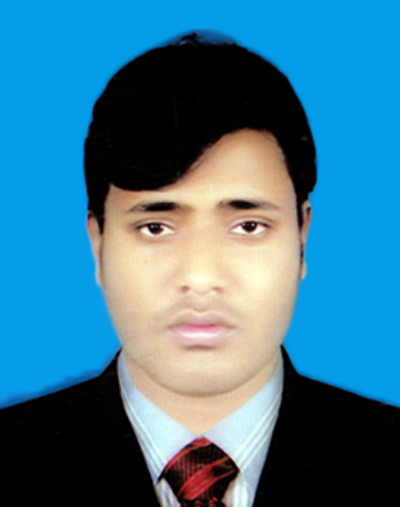
CURRICULAM VITAE
OF
MD. ANWARUL ISLAM
Cell Phone : 01774354983
CAREER OBJECTIVE :

To Estanblish a Challenging career as an enthusiastc personal through implementing my academic knowledge, analuical abilites and cerdibility that will add a derired value to the organization and ensure long-term sustainability in this modern area.

EDUCATIONAL QUALIFICATION :

B.S.C (Honurs) :
Institute : Pundra University of Scince & Technology, Bogura.
Passing Year : 2020
Result : Apperad
Department : Electrical and Electronic engineering.
Board : U.G.C.
Higher Cecondary Certifficate (Diploma)
Institute : Bogra Govt Polytechnic institute.
Passing Year : 2017
Result : 2.86 (Out of 4.00)
Department : Mining and Mine Survey Technology
Board : BTEB.

Secondary School Certificate (S.S.C):
Institute : Singurol High School.
Passing Year : 2011
Result : 4.75 (Out of 5.00)
Department : Science
Board : Dinajpur.

Core Competencies and Strengths:
COMPUTER SKILL:

Package Program : 6 Month Computer Training Information And Communication Technology, MS-Word, MS-Excel, Power Point, E-mail, Internet Browsing.

LANGUAGE PROFICIENCY :

Language Writing Reading Speaking
Bengali Excellent Excellent Excellent
English Excellent Excellent Good

P.T.O

Page- 2

PERSONAL DETAILS :

1. Name : Md. Anwarul Islam
2. Father’s Name : Md. Sirazul Islam
3. Mother’s Name : Mst. Rehena Begum
4. Mailing Address : Vill - Vomradhoho Post - Lahagora
P.S – Pirgonj Dist – Thakurgoan.
5. Permanent Address : Vill - Vomradhoho Post - Lahagora
P.S – Pirgonj Dist – Thakurgoan.
6. Home District : Thakurgoan
7. Date of Birth : 20/09/1995
8. Religion : Islam
9. Nationality : Bangladeshi
10. Marital Status : Married
11. Sex : Male
12. Mobile : 01774-354983
13. Height : 5feet 5Inch
14. Weight : 70 Kg
Training Summary :

- Industrial Attachment : Mechanical.
Work time : 6 month.
Institute name : Bangladesh Industrial Technical Assistance Center (BITAC).
- Training : Machineshop Practice.
Work time : 3 month.
Institute name : BITAC (Under SEIP Project)
1
Experience :

11

1. Instructor : Central Polytechnic institute.
work time : 2017-2018
Designation : Junior Instructor.
2.Company name : Coca- Cola Beverages and Products Ltd.
Work time : 2019-2020
Designation : Maintenance Engineer.
CONFIDENCE :

I am a smart, Young, energetic, duynamic an outgoing pleasant personality and strong enter. Personal skill with an sbility to work at a high pace on one’s won imitative.

Md. Anwarul Islam
Date :

